Use Cases

Add a Donor (Use Case #1)

|  |  |
| --- | --- |
| Actions performed by the actor | Response from the system |
| 1. Donor calls into company to request to donate to the cause. Customer service representative request for their name and phone number to look up to see if donor is new or has already have an account. Customer service representative then prompts the donor to see what they would like to do during the transaction. |  |
| 1. Representative issues a request to search the donor in the system. |  |
|  | 1. The system asks for data about the member. |
| 1. Representative enters the data into the system. |  |
|  | 1. Reads in data, and if the member can be added, generates an identification number for the donor and remembers information about the donor. Informs the representative that if the member was added and outputs the member information that was stored. |
| 1. The representative gives the user their identification number. |  |

Add a Credit Card (Use Case #2)

|  |  |
| --- | --- |
| Actions performed by the actor | Response from the system |
| 1. The representative issues a request to add a new credit card and the amount of donation. |  |
|  | 1. The system ask for the credit card ID, expiration date, CCV number, the amount, the donor’s ID, and the donor’s name. |
| 1. The representative enters the identity of the user, the credit card information, and amount. |  |
|  | 1. The system checks that the user and credit card are valid and that the credit card is not already on the member’s account. If yes, it adds the credit card and amount into the members account and displays that; otherwise, it outputs an appropriate error message. |

Process donations (Use case #3)

|  |  |
| --- | --- |
| Actions performed by the actor | Responses from the system |
| 1. The organization’s donation process date is reached. |  |
| 1. The actor issues a request to process donations |  |
|  | 1. The system charges each credit card and records the card number, amount and date for every transaction for every donor. The total amount of collected donations is displayed. |

List all transactions (Use case #4)

|  |  |
| --- | --- |
| Actions performed by the actor | Responses from the system |
| 1. The organization gets a request from a donor for some information about a transaction. |  |
| 1. The actor issues a request to list all transactions. |  |
|  | 1. The system prints the card number, amount, and date for every transaction for every donor. |
| 1. The actor relays the requested information to the donor. |  |

List all donors (Use case #5)

|  |  |
| --- | --- |
| Actions by Actor | System Response |
| 1. The actor wishes to see a list of donors. |  |
| 1. The actor issues a request to list names, ids, and phone numbers of each donor. |  |
|  | 1. The system lists the names, ids, and phone numbers of each donor. It then exits the use case. |

List specific donor (Use case #6)

|  |  |
| --- | --- |
| Actions by Actor | System Response |
| 1. The actor wishes to see a specific donor. |  |
| 1. The actor issues a request to open a search window for donors. |  |
|  | 1. The system prompts for a donor id. |
| 1. The actor enters a valid donor id. |  |
|  | 1. If the donor id is valid, the system displays the donor name, phone number, and card number, as well as the amount of all credit cards associated with the donor. It then exits the use case. Otherwise, it prints an appropriate message and returns to step 3. |

Remove specific donor (Use case #7)

|  |  |
| --- | --- |
| Actions by actor | System responses |
| 1. Donor Request to Organization to be removed as a Donor |  |
| 2. Actor Invokes the functionality to remove a specific Donor |  |
|  | 3. Asks Actor to enter a Valid Donor ID |
| 4. Actor Enters the Donor ID |  |
|  | 5. Checks to See if the Donor ID enter Exist. If not, display error message and return to step 3. If donor Does exist, all donor information is removed from system. |
| 6. Actor informs donor that they have been removed. |  |

Remove credit card (Use case #8)

|  |  |
| --- | --- |
| Actions by actor | System responses |
| 1. Donor Request to Organization to have credit card removed |  |
| 2. Actor Invokes the functionality to remove a donors credit card |  |
|  | 3. Asks Actor to enter a Valid Donor ID, and credit card number. |
| 4. Actor Enters the Donor ID, and credit card number |  |
|  | 5. Checks to See if the Donor Id, and credit card Entered are valid. If not, display error message and return to step 3. If valid, the donors credit card is removed from system. |
| 6. Actor informs donor that their credit card has been removed. |  |

Sequence Diagrams

1. Add Donor Sequence Diagram
2. Process Donations Sequence Diagram
3. List Transactions Sequence Diagram  
   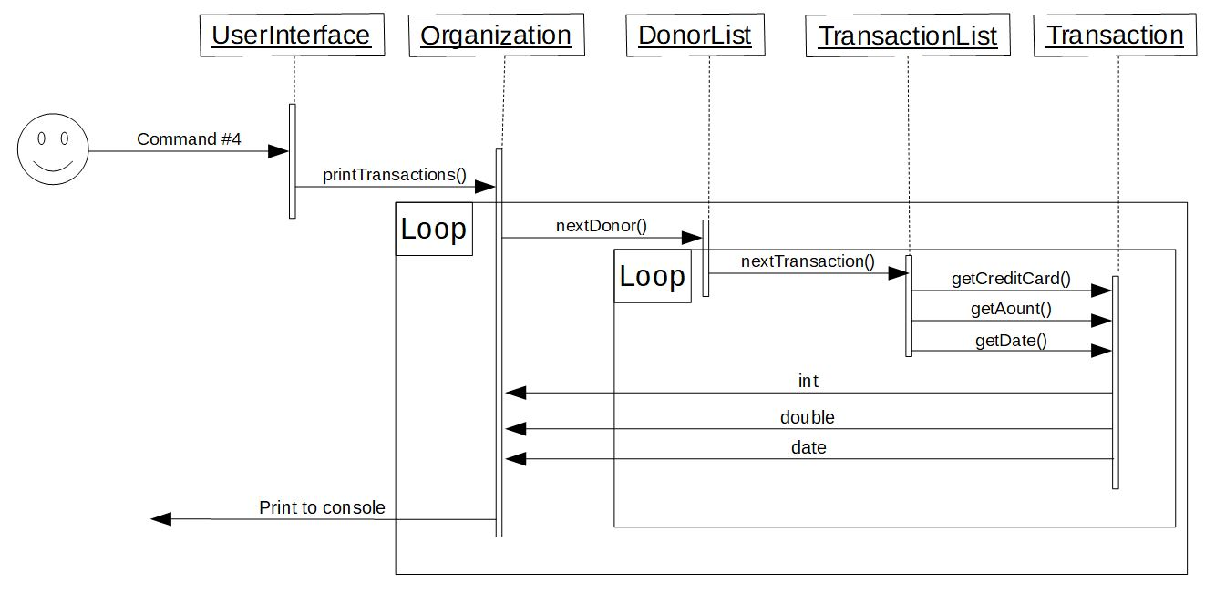

Class Relationship Diagram